**NHÓM 10 – NHN**

|  |  |
| --- | --- |
| Huỳnh Đại Nhân | 18125013 |
| Phạm Quốc Huy | 181250 |
| Mai Hoàng Nhi | 18125015 |

**ABSTRACT FACTORY**

1. **DEFINITION**

As Factory Method Pattern, Abstract Factory Pattern is one of Creational patterns.

Considered as another layer of abstraction over factory pattern.

Work around a super factory to create other factories.

The purpose of the Abstract Factory is to provide an interface for creating families of related objects, without specifying concrete classes.

1. **PROBLEM**

Imagine that you’re drawing many shapes. Your code consists of classes that represent:

1. Shape, RoundedShape

2. Shape and RoundedShape are also have Square, Rectangle,... You need to creat individual objects so that they match other objects of the same type. Also, you don't want to change existing code when adding new shape or type of shape

1. **SOLVE**
2. **Normal**

|  |
| --- |
| #include <iostream>  #include <fstream>  #include <string>  using namespace std;  class Shape  {  private:  public:  void draw();  };  class RoundedRectangle : public Shape  {  private:  public:  void draw();  };  class Rectangle : public Shape  {  private:  public:  void draw();  };  void Shape::draw()  {  #ifdef RECTANGLE  Shape *shape = new Rectangle;  #else  Shape *shape = new RoundedRectangle;  #endif  shape->draw();  }  void RoundedRectangle::draw()  {  cout << "Rounded Rectangle" << endl;  }  void Rectangle::draw()  {  cout << "Rectangle" << endl;  }  int main()  {  Shape *shape = new Shape();  shape->draw();  return 0;  } |

1. **Abstract Factory**

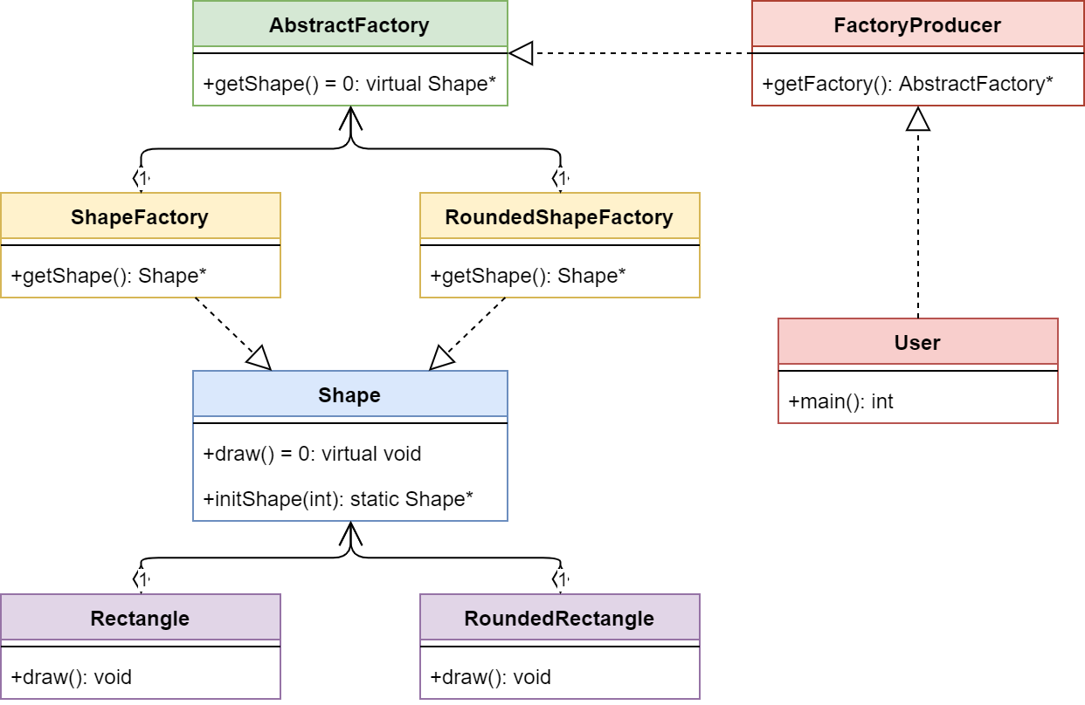

|  |
| --- |
| #include <iostream>  #include <fstream>  #include <string>  #include <vector>  using namespace std;  class AbstractFactory  {  private:  public:  virtual Shape *getShape() = 0;  };  class FactoryProducer  {  private:  public:  AbstractFactory *getFactory();  };  class Rectangle : public Shape  {  private:  public:  void draw();  };  class RoundedRectangle : public Shape  {  private:  public:  void draw();  };  class RoundedShapeFactory : public AbstractFactory  {  private:  public:  Shape *getShape();  };  class Shape  {  private:  public:  static Shape* initShape(int);  virtual void draw() = 0;  };  class ShapeFactory : public AbstractFactory  {  private:  public:  Shape *getShape();  };  AbstractFactory *FactoryProducer::getFactory()  {  int type;  do  {  cout << "1: Rectangle, 2: Rounded Rectangle" << endl;  cin >> type;  } while (type < 1 || type > 2);  if (type == 1)  return new ShapeFactory;  else if (type == 2)  return new RoundedShapeFactory;  return nullptr;  }  void RoundedRectangle::draw()  {  cout << "Rounded Rectangle" << endl;  }  Shape *Shape::initShape(int type)  {  if (type == 1)  return new Rectangle;  else if (type == 2)  return new RoundedRectangle;  else  return nullptr;  }  Shape *ShapeFactory::getShape()  {  return Shape::initShape(1);  }  int main()  {  FactoryProducer FP;  AbstractFactory *a = FP.getFactory();  Shape *s1 = a->getShape();  s1->draw();  FactoryProducer FP1;  AbstractFactory *a1 = FP1.getFactory();  Shape *s2 = a1->getShape();  s2->draw();  return 0;  } |

1. **Comparasion**
2. **STRUCTURE**

* AbstractFactory : Declares an interface for operations that create abstract product objects.
* ConcreteFactory : Implements the operations declared in the AbstractFactory to create concrete product objects.
* Product : Defines a product object to be created by the corresponding concrete factory and implements the AbstractProduct interface.
* Client : Uses only interfaces declared by AbstractFactory and AbstractProduct classes.

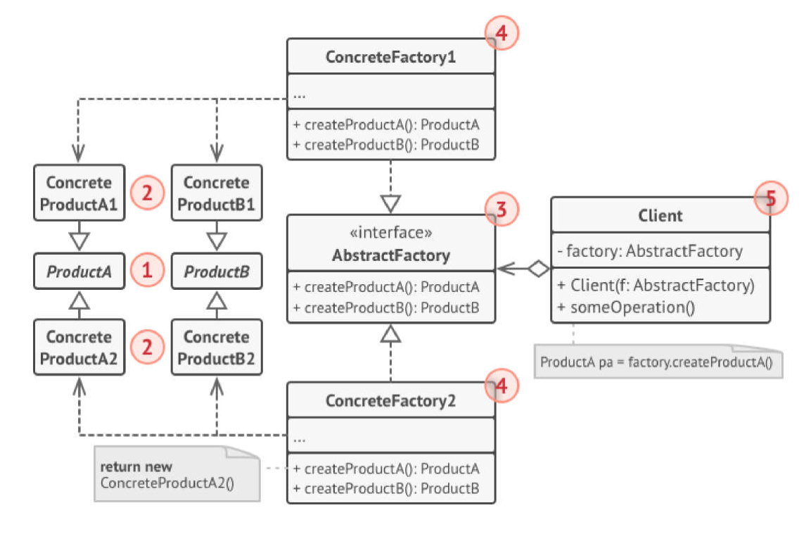

1. **ADVANTAGES & DISADVANTAGES**

|  |  |
| --- | --- |
| **ADVANTAGE** | **DISADVANTAGE** |
| * Ensure that all products you receive from a factory are compatible. * Cut down the dependence between creator and concrete products. * Create products into somewhere in the program 🡪 easy to track and manipulate. * Freely add many new products to the program without changing the existing code base. | * Code will be more complicated and must use a lot of classes. |

1. **SOME MORE PROBLEM/ EXAMPLE**

* **Phone Number Example**

The example at the beginning of the article can be extended to addresses, too. The AbstractFactory class will contain methods for creating a new entry in the information manager for a phone number and for an address, methods that produce the abstract products Address and PhoneNumber, which belong to AbstractProduct classes. The AbstractProduct classes will define methods that these products support: for the address get and set methods for the street, city, region and postal code members and for the phone number get and set methods for the number.

The ConcreteFactory and ConcreteProduct classes will implement the interfaces defined above and will appear in our example in the form of the USAddressFactory class and the USAddress and USPhoneNumber classes. For each new country that needs to be added to the application, a new set of concrete-type classes will be added. This way we can have the EnglandAddressFactory and the EnglandAddress and EnglandPhoneNumber that are files for English address information.

* **Pizza Factory Example**

Another example, this time more simple and easier to understand, is the one of a pizza factory, which defines method names and returns types to make different kinds of pizza. The abstract factory can be named AbstractPizzaFactory, RomeConcretePizzaFactory and MilanConcretePizzaFactory being two extensions of the abstract class. The abstract factory will define types of toppings for pizza, like pepperoni, sausage or anchovy, and the concrete factories will implement only a set of the toppings, which are specific for the area and even if one topping is implemented in both concrete factories, the resulting pizzas will be different subclasses, each for the area it was implemented in.

* **Look & Feel Example**

Look & Feel Abstract Factory is the most common example. For example, a GUI framework should support several look and feel themes, such as Motif and Windows look. Each style defines different looks and behaviors for each type of controls: Buttons and Edit Boxes. In order to avoid the hardociding it for each type of control we define an abstract class **LookAndFeel**. This calls will instantiate, depending on a configuration parameter in the application one of the concrete factories: **WindowsLookAndFeel** or **MotifLookAndFeel**. Each request for a new object will be delegated to the instatiated concrete factory which will return the controls with the specific flavor

1. **REFERENCE**

<https://sourcemaking.com/design_patterns/abstract_factory>

<https://www.geeksforgeeks.org/abstract-factory-pattern/>

<https://www.oodesign.com/abstract-factory-pattern.html>